大作业二

图书管理系统

姓名：陈炜俊 学号：20222005195

注：前面为运行结果，代码在后面

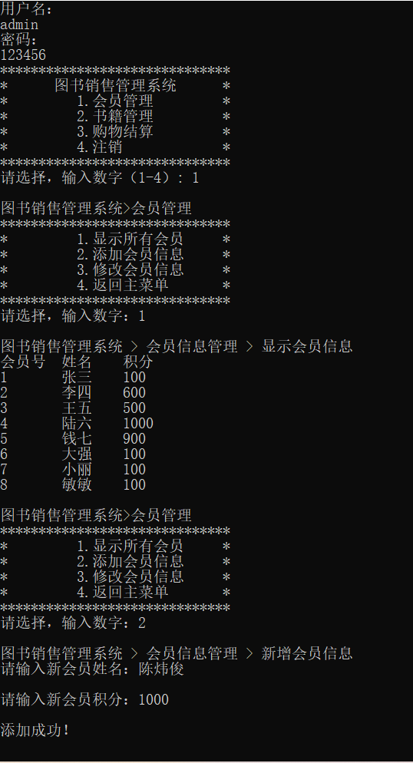

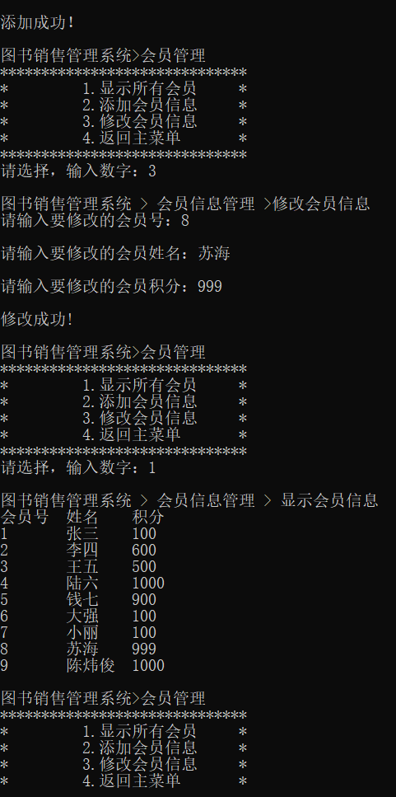

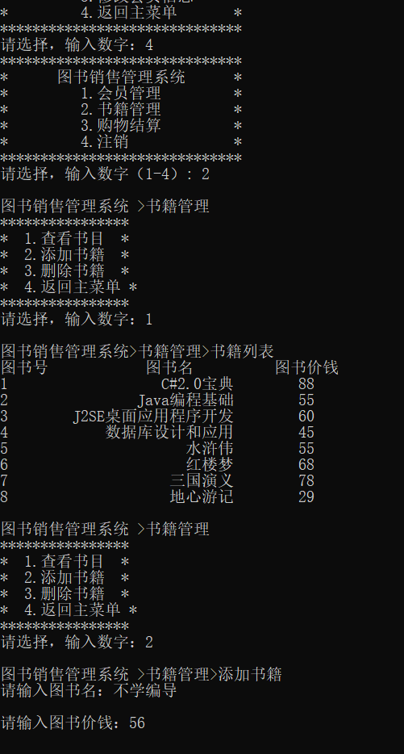

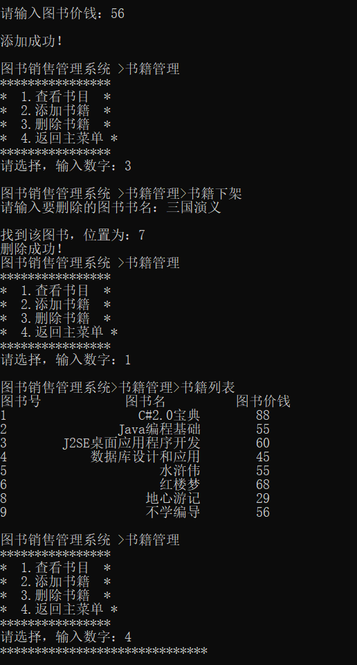

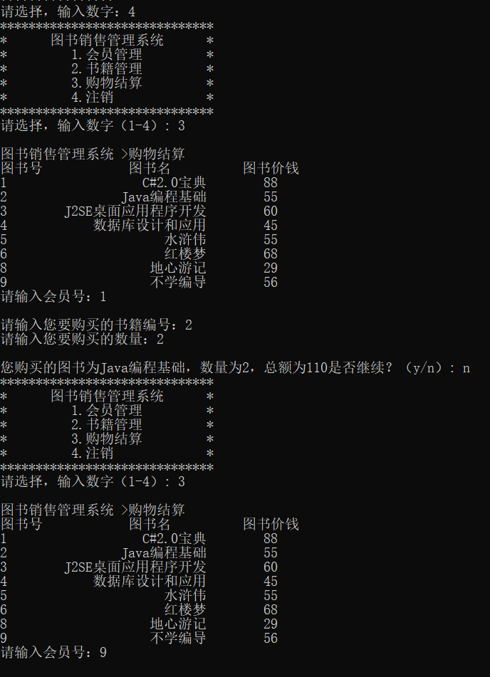

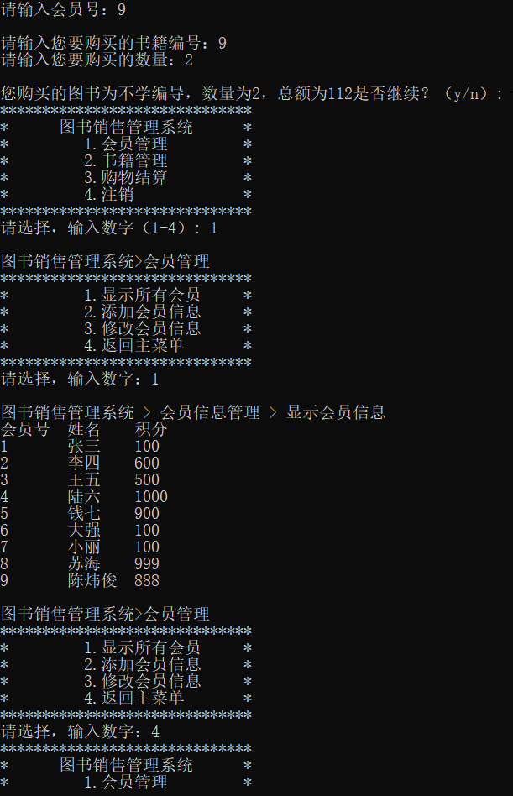

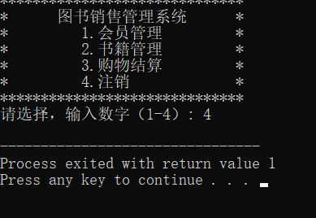

#include <stdio.h>

#include <string.h>

#include <stdlib.h>

#include <string.h>

int huiyuanhao[50] = {0,1,2,3,4,5,6,7,8,};

int n = 8;

struct jiegou{

int shu;

char ming[50][10];

}p1,p2;

int jifen[50] = {0,100,600,500,1000,900,100,100,100,};

char xingming[50][10] = {"0","张三","李四","王五","陆六","钱七","大强","小丽","敏敏"};

char \*xingming1[50];

void zhanghaomima(void);

void printmulu(void);

void huiyuanguanli(void);

void shujiguanli(void);

void gouwujiesuan(void);

void zhuxiao(void);

void xianshihuiyuan(void);

void tianjiahuiyuan(void);

void xiugaihuiyuan(void);

void chakanshumu(void);

void tianjiashuji(void);

void shanchushuji(void);

void gouwujiesuan(void);

int p = 8;

int tushuhao[50] = {0,1,2,3,4,5,6,7,8,};

char tushuming[50][50] = {"0","C#2.0宝典","Java编程基础","J2SE桌面应用程序开发","数据库设计和应用","水浒伟","红楼梦","三国演义","地心游记",};

char \*tushuming1[50];

int tushujiaqian[50] = {0,88,55,60,45,55,68,78,29};

int main(){

zhanghaomima();

return 0;

}

//购物结算

void gouwujiesuan(void){

printf("\n图书销售管理系统 >购物结算\n");

int i;

for(i=1;i<=p;i++){

tushuming1[i] = tushuming[i];

}

printf("图书号 图书名 图书价钱\n");

for(i=0;i<=p;i++){

if(tushuhao[i] == 0){

continue;

}

printf("%d %20s %d\n",tushuhao[i],tushuming1[i],tushujiaqian[i]);

}

printf("请输入会员号：");

int j;

scanf("%d",&j);

printf("\n请输入您要购买的书籍编号：");

int bianhao;

scanf("%d",&bianhao);

printf("请输入您要购买的数量：");

int shuliang=1;

scanf("%d",&shuliang);

printf("\n您购买的图书为%s，数量为%d，总额为%d",tushuming[bianhao],shuliang,shuliang\*tushujiaqian[bianhao]);

printf("是否继续？（y/n）: ");

char qw;

scanf(" %c",&qw);

if(qw == 'n'){

printmulu();

}

else{

jifen[j] = jifen[j] - shuliang\*tushujiaqian[j];

printmulu();

}

}

//删除书籍

void shanchushuji(void){

printf("\n图书销售管理系统 >书籍管理>书籍下架\n");

printf("请输入要删除的图书书名：");

char zhetushu[50] = "";

scanf("%s",zhetushu);

int i,j=0;

for(i=1;i<=p;i++){

if(strcmp(tushuming[i],zhetushu)==0){

j=i;

}

}

printf("\n找到该图书，位置为：%d\n",j);

tushuhao[j]=0;

tushujiaqian[j] = 0;

char gongjuren[50] = "0";

strcpy(tushuming[j],gongjuren);

printf("删除成功！");

shujiguanli();

}

//添加书籍

void tianjiashuji(void){

printf("\n图书销售管理系统 >书籍管理>添加书籍\n");

p++;

tushuhao[p] = p;

printf("请输入图书名：");

scanf("%s",&tushuming[p]);

printf("\n请输入图书价钱：");

scanf("%d",&tushujiaqian[p]);

printf("\n添加成功！\n");

shujiguanli();

}

//查看书目

void chakanshumu(void){

printf("\n图书销售管理系统>书籍管理>书籍列表\n");

int i;

for(i=1;i<=p;i++){

tushuming1[i] = tushuming[i];

}

printf("图书号 图书名 图书价钱\n");

for(i=0;i<=p;i++){

if(tushuhao[i] == 0){

continue;

}

printf("%d %20s %d\n",tushuhao[i],tushuming1[i],tushujiaqian[i]);

}

shujiguanli();

}

//修改会员

void xiugaihuiyuan(void){

printf("\n图书销售管理系统 > 会员信息管理 >修改会员信息\n");

printf("请输入要修改的会员号：");

int j;

scanf("%d",&j);

printf("\n请输入要修改的会员姓名：");

scanf("%s",xingming1[j]);

printf("\n请输入要修改的会员积分：");

scanf("%d",&jifen[j]);

printf("\n修改成功!\n");

huiyuanguanli();

}

//主菜单

void printmulu(void){

printf("\*\*\*\*\*\*\*\*\*\*\*\*\*\*\*\*\*\*\*\*\*\*\*\*\*\*\*\*\*\*\n\* 图书销售管理系统 \*\n\* 1.会员管理 \*\n\* 2.书籍管理 \*\n\* 3.购物结算 \*\n\* 4.注销 \*\n\*\*\*\*\*\*\*\*\*\*\*\*\*\*\*\*\*\*\*\*\*\*\*\*\*\*\*\*\*\*\n");

printf("请选择，输入数字（1-4）: ");

int shuru;

scanf("%d",&shuru);

switch(shuru){

case 1:

huiyuanguanli();

break;

case 2:

shujiguanli();

break;

case 3:

gouwujiesuan();

break;

case 4:

zhuxiao();

break;

}

}

//会员管理

void huiyuanguanli(void){

printf("\n图书销售管理系统>会员管理\n");

int j = 0;

printf("\*\*\*\*\*\*\*\*\*\*\*\*\*\*\*\*\*\*\*\*\*\*\*\*\*\*\*\*\*\*\n\* 1.显示所有会员 \*\n\* 2.添加会员信息 \*\n\* 3.修改会员信息 \*\n\* 4.返回主菜单 \*\n\*\*\*\*\*\*\*\*\*\*\*\*\*\*\*\*\*\*\*\*\*\*\*\*\*\*\*\*\*\*\n");

printf("请选择，输入数字：") ;

scanf("%d",&j);

int o;

for(o=0;o<=n;o++){

xingming1[o] = xingming[o];

}

switch(j){

case 1:

xianshihuiyuan();

break;

case 2:

tianjiahuiyuan();

break;

case 3:

xiugaihuiyuan();

break;

case 4:

printmulu();

break;

}

}

//书籍管理

void shujiguanli(void){

printf("\n图书销售管理系统 >书籍管理\n");

printf("\*\*\*\*\*\*\*\*\*\*\*\*\*\*\*\*\n\* 1.查看书目 \*\n\* 2.添加书籍 \*\n\* 3.删除书籍 \*\n\* 4.返回主菜单 \*\n\*\*\*\*\*\*\*\*\*\*\*\*\*\*\*\*\n");

printf("请选择，输入数字：");

int j;

scanf("%d",&j);

switch(j){

case 1:

chakanshumu();

break;

case 2:

tianjiashuji();

break;

case 3:

shanchushuji();

break;

case 4:

printmulu();

break;

}

}

//注销

void zhuxiao(void){

exit(1);

}

//账号密码

void zhanghaomima(void){

char biaozhunyonghuming[10] = "admin";

long biaozhunmima = 123456;

char yonghuming [10] = "";

long mima;

int i = 0;

printf("用户名：\n");

scanf("%s",yonghuming);

printf("密码：\n");

scanf("%ld",&mima);

while(strcmp(yonghuming,biaozhunyonghuming)!=0||mima!=biaozhunmima){

if(i==2){

printf("机会用完，退出系统");

exit(1);

}

printf("\n账号或者密码错误，请再次输入\n");

i++;

printf("用户名：\n");

scanf("%s",yonghuming);

printf("密码：\n");

scanf("%ld",&mima);

}

printmulu();

}

//显示会员

void xianshihuiyuan(void){

printf("\n图书销售管理系统 > 会员信息管理 > 显示会员信息\n");

int i;

printf("会员号\t姓名\t积分\n");

for(i=1;i<=n;i++){

printf("%d\t%s\t%d\n",i,xingming1[i],jifen[i]);

}

huiyuanguanli();

}

//添加会员

void tianjiahuiyuan(void){

printf("\n图书销售管理系统 > 会员信息管理 > 新增会员信息\n");

n++;

printf("请输入新会员姓名：");

scanf("%s",&xingming[n]);

printf("\n请输入新会员积分：");

scanf("%d",&jifen[n]);

printf("\n添加成功！\n");

huiyuanguanli();

}